
HOW TO MAKE CHANGES TO YOUR COMPETITION ENTRY – (VFE-Verification Final Entry)
www.weightlifting.nz
Calendar
Click on competition that you entered
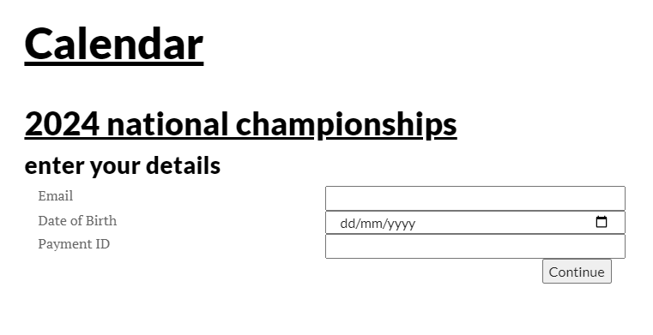
Enter your email
Enter your DOB
Payment ID- you find on the confirmation email you received after your original entry.
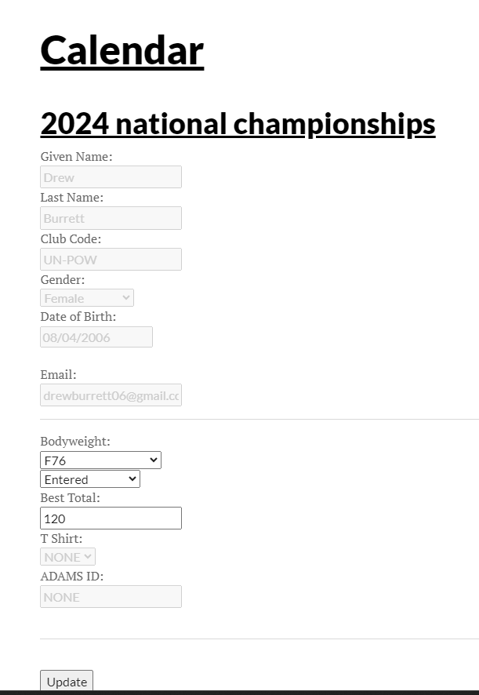
TO WITHDRAW FROM COMPETITION – CLICK “ENTERED” AND SELECT WITHDRAWN

